# 1、新建一个struts项目

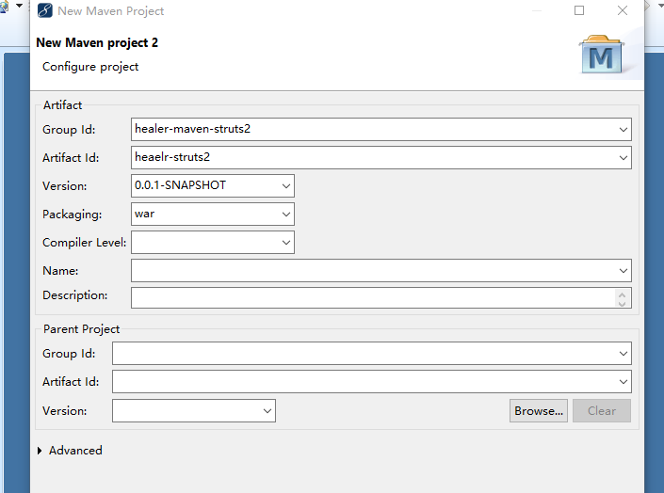

|  |
| --- |
| <project xmlns=*"http://maven.apache.org/POM/4.0.0"* xmlns:xsi=*"http://www.w3.org/2001/XMLSchema-instance"* xsi:schemaLocation=*"http://maven.apache.org/POM/4.0.0 http://maven.apache.org/xsd/maven-4.0.0.xsd"*>  <modelVersion>4.0.0</modelVersion>  <groupId>healer-maven-struts2</groupId>  <artifactId>heaelr-struts2</artifactId>  <version>0.0.1-SNAPSHOT</version>  <packaging>war</packaging>  <build/>  </project> |

# 2、添加struts的依赖

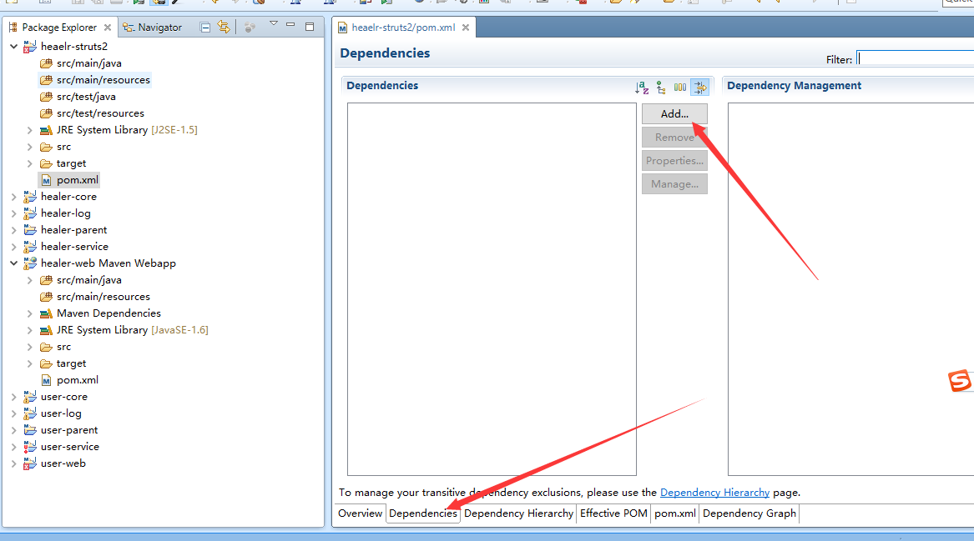

## 1、输入Struts

